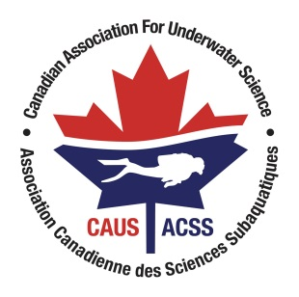
Canadian Association for Underwater Science
Scholarship Application Form

Candidate Details

Name:
Email:
Phone:

Post-Secondary Educational Institution

Name:
Academic Program and Year(s) of Study:

Academic Advisor or Project Supervisor

Name:
Title:
Institutional Address:
Email:
Phone:

Project Details

- Outline your research, educational or training program and how it relates to scientific diving. (350-word limit)
- Describe how your project uses, develops, advances or otherwise contributes to the culture of safe scientific diving practices, and how scientific diving is essential for the successful completion of the proposed work. (350-word limit)
- Identify the major contribution(s) to the research, scientific, or educational community that will result from your project. (350-word limit)

Support Materials

- Include a current resume or curriculum vitae.
- Include current academic transcripts of completed and in-progress courses.
- Include a letter of support from your academic advisor.
- Include a letter from your Diving Safety Officer stating your current level of scientific diving certification (only necessary if you are diving as part of your project) and compliance with your institution’s code of safe diving practices.
- Include any additional documents (e.g. c-cards, publications, Abstracts, letters of reference, etc.) you wish to supply that may help the Committee assess your application.

